EXPERIMENT 4

ROLL NO: 240701529 NAME: Sri Vaishnavi A
Create a prototype with familiar and unfamiliar navigation elements. Evaluate ease of use with different user groups using proto.io

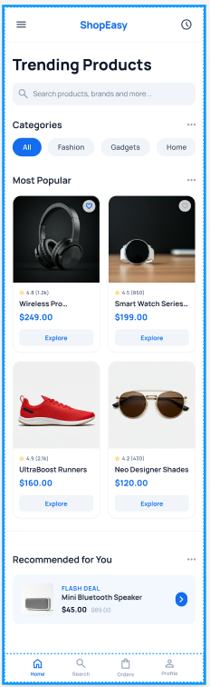
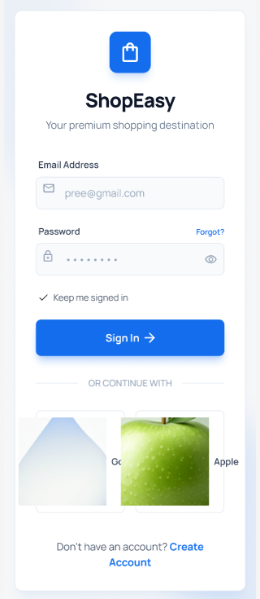
Screen -01 Screen -02

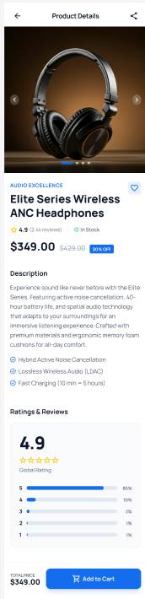
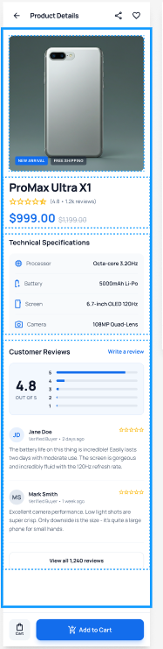
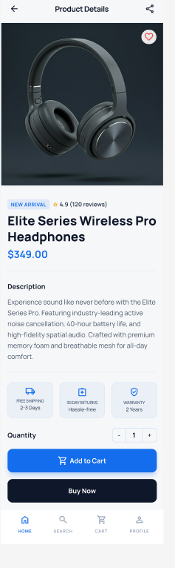
Screen-03 Screen-04 Screen-05

Home page:
Familiar Icons:
1. Hamburger Menu (☰) - Top Left: o A common icon representing a collapsible navigation menu. o Clicking it usually opens a sidebar with options like Home, Settings, and Profile.
2. Search Icon (🔍) - Below the Heading: o A widely recognized icon used for searching within the app. o Clicking it typically opens a search bar where users can type queries.
3. Three-Dot Menu (⋮) - Near "Trending Styles": o Represents more options or actions related to the section. o Often used for settings, sorting, or additional functionalities.

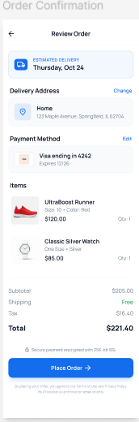
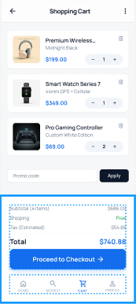
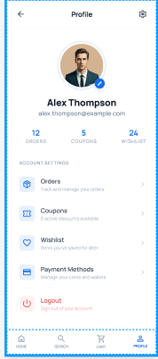
Screen-06 Screen-07 Screen-08
Screen-09



Familiar Icons:
1. Profile Icon (Circle Placeholder - Top Left): o Represents the user's profile picture or avatar. o Clicking it may allow users to edit their profile or view account details.

2. Transaction Icon (💳or similar) - Next to "Transaction": o Commonly used for payments, purchases, or financial records. o Clicking it likely opens transaction history.

3. Coupons Icon (🎟️ or Tag Symbol) - Next to "Coupons": o Represents discounts, offers, or vouchers. o Clicking it may show available coupons for the user.

4. Heart Icon - Next to "Favourite": o A universally recognized icon for saved or liked items. o Clicking it will likely show favorite places, hotels, or deals.

5. Logout Icon (⏻ or ↩) - Next to "Log out": o Commonly represents signing out of an account. o Clicking it will log the user out of the app.

6. Back Arrow (←) - Top Left Corner: o A widely recognized navigation icon. o Clicking it will take the user back to the previous screen.

7. Left & Right Arrows (⟵ ⟶) - Near the Month Name (February 2025): o These are used to navigate between months in the calendar. o Clicking them allows users to select different check-in and check-out dates.

8. Calendar View with Highlighted Date (22): o A standard UI element in booking applications. o The selected date is highlighted, indicating the user's check-in/check-out selection.

9. "Reserve" Button - Bottom Right: o A common call-to-action (CTA) button. o Clicking it likely confirms the selected dates for booking.

10. Back Arrow (←) - Top Left Corner: o A common navigation icon used in almost all mobile apps. o Clicking it will take the user back to the previous screen.

11. Star Icon (⭐) - Rating Indicator: o Represents the rating of the resort (4.5 stars). o A familiar UI element used in travel, e-commerce, and review-based apps.

12. Payment Button ("Pay") - Bottom Center: o A standard call-to-action (CTA) button used for confirming transactions. o Clicking it will likely redirect the user to a payment gateway.

